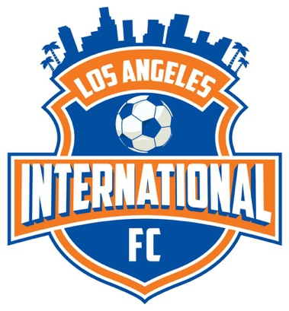
Los Angeles International FC
340 Burchett St., Unit 314 Glendale, CA 91203
E-mail: info@lainternationalfc.com
Tel: 818-724-8181
Donation Letter
Since 2017, Los Angeles International FC has touched the lives of hundreds of Los Angeles County’s youth, ranging in ages from 4 to 18. LA International FC, as a Nationally ranked youth soccer program, is committed to the development of each child’s potential both as a player and as a person.
Our club believes that the pursuit of excellence in the areas of academics and soccer helps develop maturity, a strong work ethic and confidence. Our coaches encourage teamwork, good sportsmanship, physical fitness, hard work, persistence and focus. Many of our youth not only develop into great soccer players but also create friendships and mentoring relationships that carry them well into adulthood. We believe that soccer is a great education and great network resource for the children in future that can help them throughout their life.
The goals of the LA International Soccer Club are to develop each player to his/her fullest potential, to provide positive role models, to expose players to collegiate and professional opportunities and develop National Championship caliber teams. Our club will do everything possible for those children who need extra trainings for their college scholarships. We will also use our recourses to promote them to play at a professional level.
The LA International FC has an excellent licensed coaching staff. We organize camps and tournaments. We play in different state and local tournaments.
The LA International FC is a non-profit 501(c)(03) organization.
Playing soccer is fun but it is also expensive for a lot of families. Additionally, the club does assist some families with the cost of participation depending on their financial situation. Our club’s main goal is to cover some uniform, equipment, tournament, and traveling fees as well. This is why we are kindly asking you to help us. Let’s make it possible for every child to play soccer.
If you want to make a donation, please fill out and send in the bottom portion of this letter along with your donation.
Thank you,
Los Angeles International FC

*** Please make checks payable to Los Angeles International FC. If you would like to donate to a specific team, please make a note on the attached form. You can also mail your donations to FC 340 Burchett St., Unit 314 Glendale, CA 91203.

I would like to donate $ to Los Angeles International FC to Team
Full Name:
Business Name:
Address:
Tel: E-mail:

